**BIRDRAKSHA:**

**Analysis Graphs and Their Summary**

1]

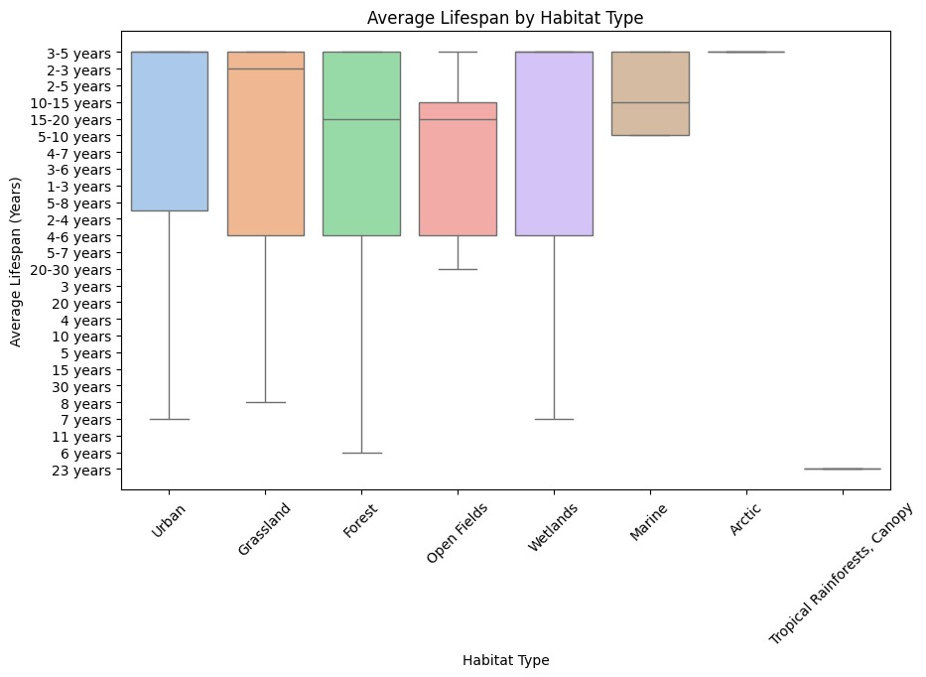

The average lifespan of animals across different habitat types is analysed using a box plot, which shows notable variation. Urban, grassland, forest, and wetland habitats are examples of terrestrial environments with similar median values and wide lifespan ranges (1 to 30 years). The tropical rainforest canopy exhibits the shortest and most stable longevity (about 6 years), whereas marine and Arctic settings have longer average lifespans with less fluctuation. These results demonstrate how habitat type affects species longevity and imply that environmental factors significantly impact lifespan distribution.

2]

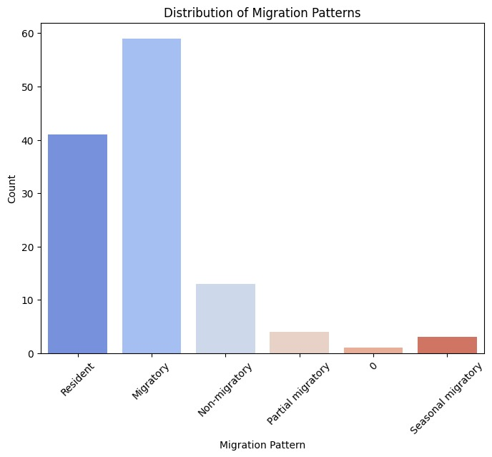

The distribution of migration trends across several categories is depicted in the bar chart. With about 60 species, migratory species are the most prevalent, followed by resident species with 40. The number of non-migratory species is much lower, at about 12, whilst seasonal and partial migratory species are uncommon. There is another one unclassified category, but it is small. According to this distribution, resident and migratory patterns predominate, with other forms of migration being comparatively rare.

3]

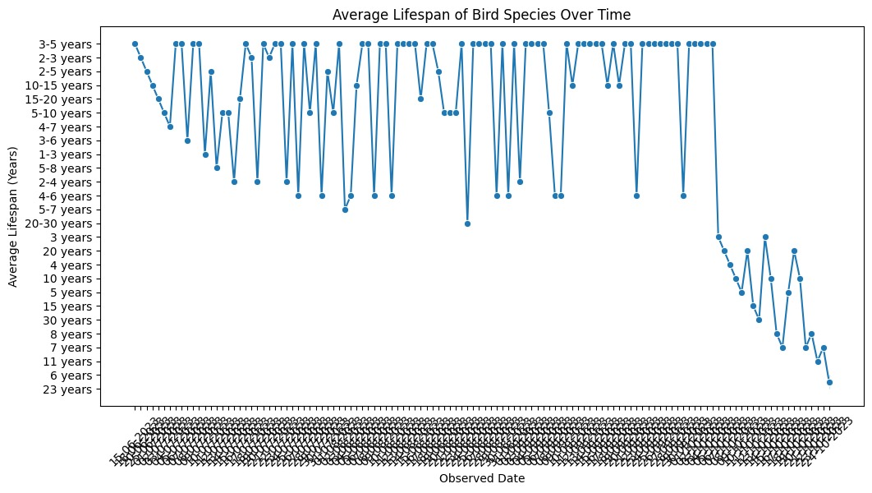

The average lifetime of bird species over time is shown in the line chart, which shows variability between observed dates. Most species have an average 3-7 years lifespan, with lifespans ranging from 1-30 years. The latter portion of the timeline shows a decline in longevity, whilst the first and middle sections display fluctuations without a distinct trend. This implies that biological or environmental factors may impact birds' longevity over time.

4]

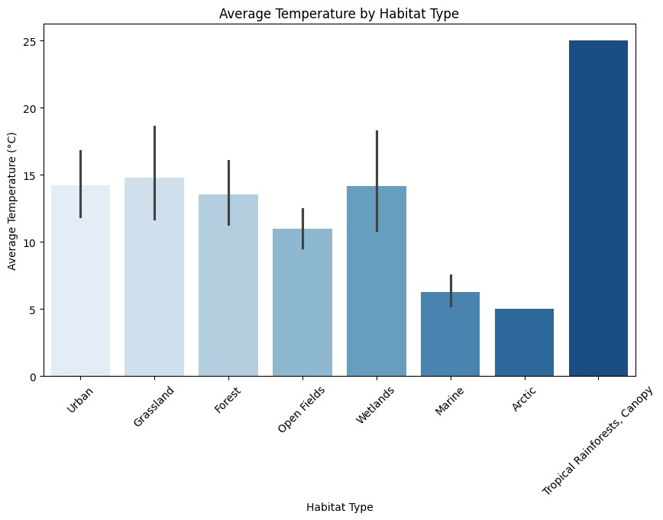

The average temperature for each type of habitat is displayed in a bar chart, highlighting significant variations:  
  
The mild temperatures in urban, grassland, forest, and wetland areas range from 13°C to 15°C, with slightly more variability in wetlands.  
The lowest average temperatures are seen in marine and arctic ecosystems (~7°C and ~5°C, respectively), whereas open fields are colder at ~11°C.  
With the greatest temperature (around 25°C), the Tropical Rainforest Canopy has a considerably warmer climate than the other habitats.  
Grasslands and wetlands exhibit the greatest temperature volatility, according to the error bars, which indicate variance within each habitat.

5]

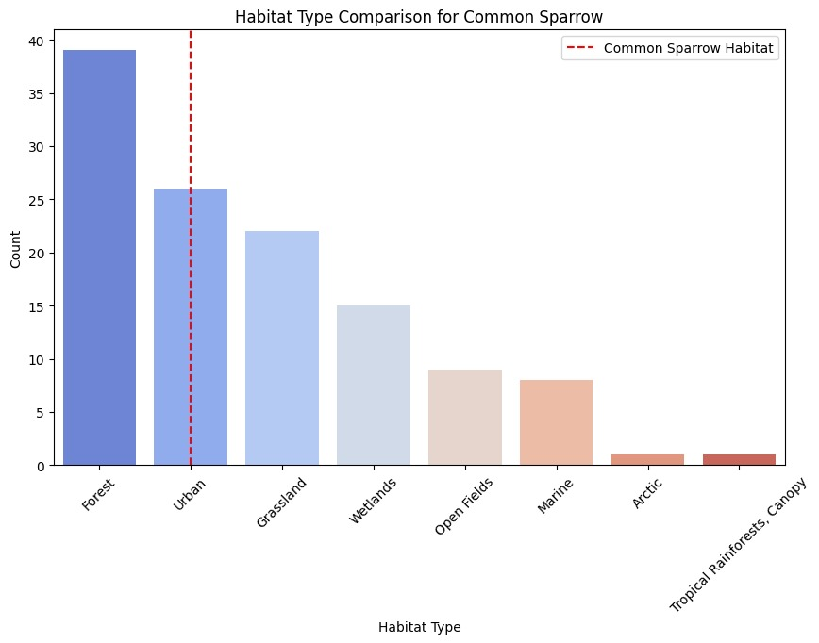

The habitat distribution of the Common Sparrow across different settings is displayed in the second bar chart:   
  
1. Forest is the most frequent habitat for the Common Sparrow, with the highest count (~38).   
2. The red dashed line designating Urban as a critical habitat indicates that sparrows are significantly present in Urban areas (~27) and Grasslands (~22).   
3. The sparrow population is moderate in Wetlands (~15) and Open Fields (~10).   
4. Sparrows are minimally present in the Marine, Arctic, and Tropical Rainforest Canopy environments, with counts below 5.   
  
While Forests continue to be sparrows' primary habitat, the red dashed line indicates that Urban habitats are an important area.

6]

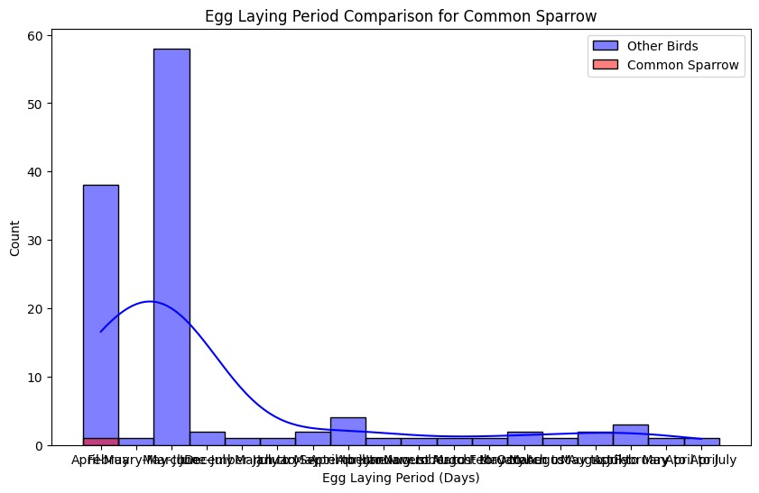

The distribution of egg-laying periods for Common Sparrow (in red) and Other Birds (in blue) is displayed in the Egg Laying Period Comparison for Common Sparrow chart:   
  
1. Months of Peak Laying:   
Other birds lay the most eggs in April and May, with May having the highest number (~60).   
In comparison to other birds, the Common Sparrow produces eggs mostly throughout these months as well, although in smaller numbers.   
  
2. Laying Distribution of Eggs:   
For both groups, egg-laying sharply decreases after May.   
After July, there are few occurrences, and August to March is when there is the least amount of activity.   
  
3. Trend Analysis:   
Although it aligns with other birds, the Common Sparrow's egg-laying pattern is less frequent overall.   
The density curve shows that the spring season (April-May) is when most egg-laying occurrences occur.

7]

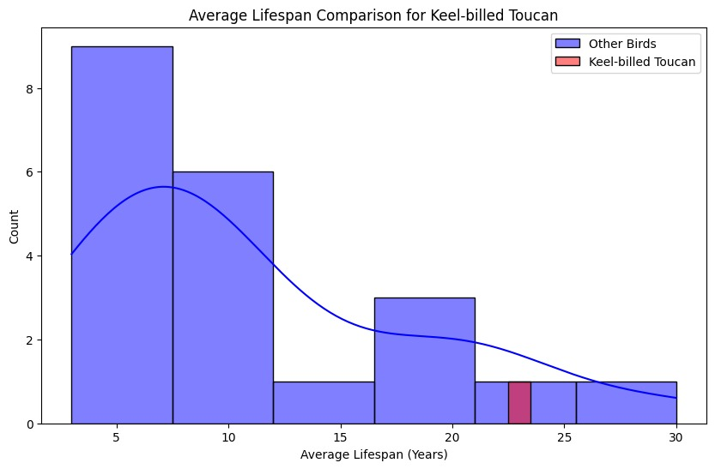

In comparison to most other birds, which normally have lifespans of 3 to 10 years, the Keel-billed Toucan has a substantially longer lifespan (~25 years). This demonstrates the Keel-billed Toucan's exceptional longevity in comparison to other bird species.

8]

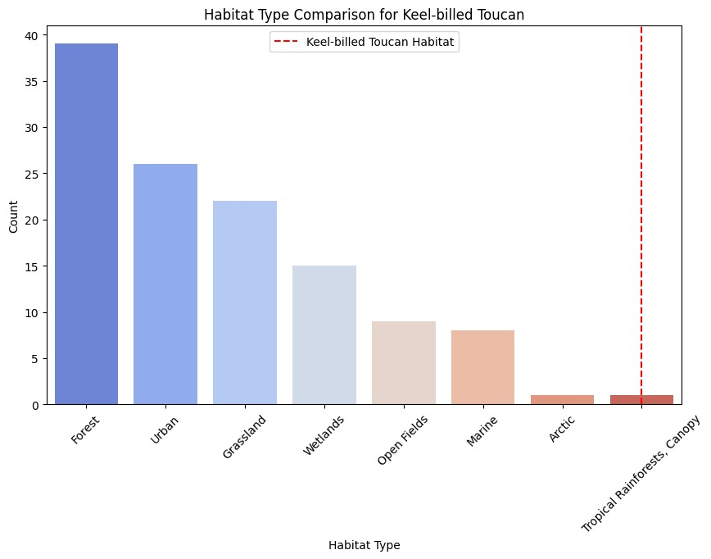

In contrast to the most typical habitats of other bird species, which include forests, urban areas, and grasslands, the Keel-billed Toucan mostly lives in tropical rainforests and canopy regions. In contrast to other bird species, this demonstrates the specific and unique environmental requirements of the Keel-billed Toucan.

9]

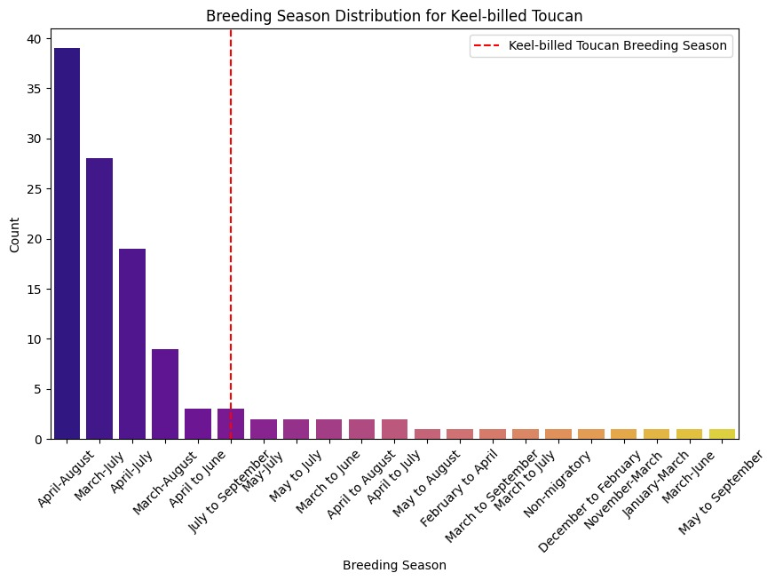

The Keel-billed Toucan is less common than other bird species, with a breeding season from May to September. The Keel-billed Toucan's breeding season is slightly later and more specialized than that of most other birds, which breed between April and August. This implies that their cycle of reproduction is tailored to particular environmental circumstances.

10]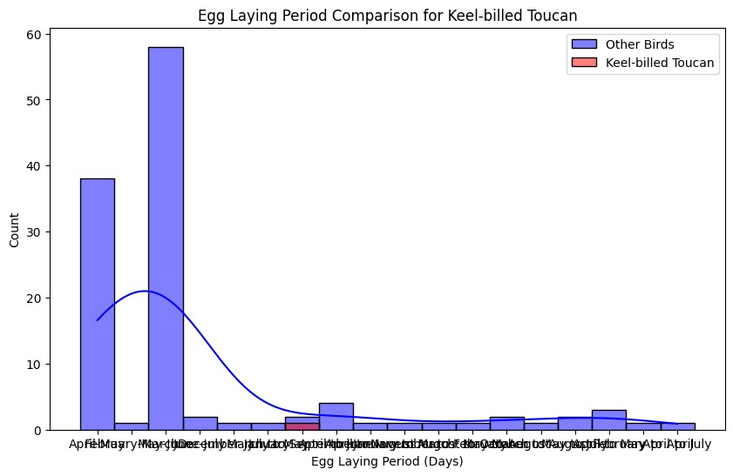

Compared to other bird species, the Keel-billed Toucan has a shorter and less frequent egg-laying period. The Keel-billed Toucan has a distinctive and later egg-laying season, whereas the majority of other birds have a peak egg-laying period during April and May. This implies that the Keel-billed Toucan has a unique reproductive timeline that may be connected to particular ecological or environmental elements.

11]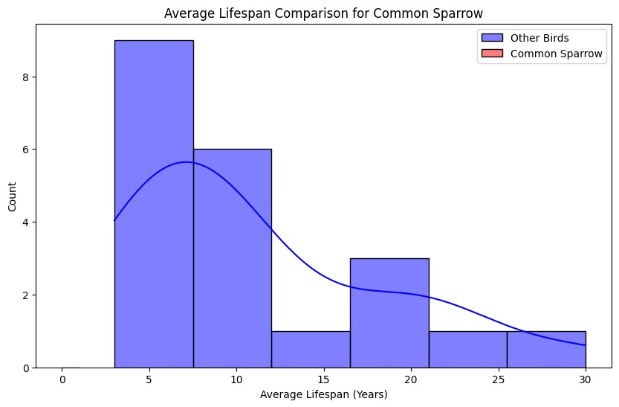

Compared to many other bird species, some of which can live up to 30 years, the Common Sparrow usually lives 5-10 years. The longevity of most birds is comparable, although certain species exhibit longer survival because of better adaptations. This comparison emphasizes the necessity for conservation efforts by highlighting the impact of environmental factors on the Common Sparrow's short lifespan.